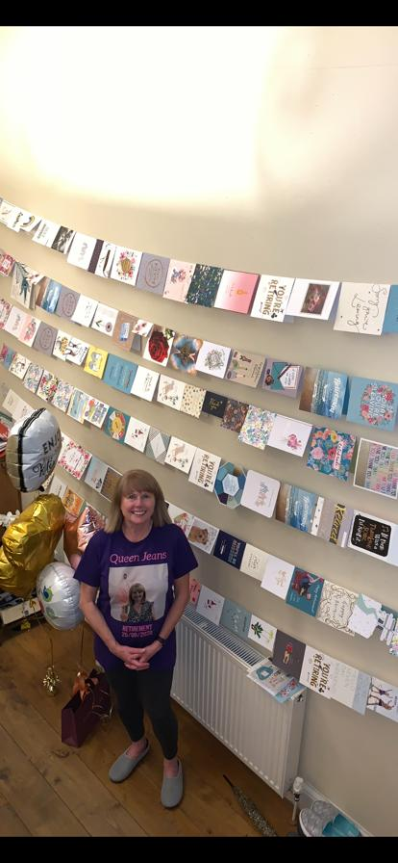

Dr Powell would like to thank all the patients for their kind words, many cards and generous gifts they so kindly gave her for her retirement from the Practice.