**Kessington Medical Centre Newsletter**

C:\Program Files\Microsoft Office\MEDIA\CAGCAT10\j0298897.wmfC:\Program Files\Microsoft Office\MEDIA\CAGCAT10\j0298897.wmfC:\Program Files\Microsoft Office\MEDIA\CAGCAT10\j0298897.wmfC:\Program Files\Microsoft Office\MEDIA\CAGCAT10\j0298897.wmfC:\Program Files\Microsoft Office\MEDIA\CAGCAT10\j0298897.wmf

85 Milngavie Road Bearsden G61 2DN Telephone 0141 212 0700

**Autumn** **Issue September 2018 Useful Telephone Numbers**

Appointments 0141 212 0700 Repeat Prescriptions 0141 406 6380

District Nurses 0141 232 4817 Health Visitors 0141 232 4815

Ante Natal 0141 232 4005 Out of Hours 111

  

**Flu Vaccinations**

The flu season is upon us once again. The flu vaccine protects people over 65, those who have health conditions and pregnant women against the strains of flu virus that are likely to be circulating. Please note that there are no open clinics this year and the vaccination is going to be given by appointment instead.

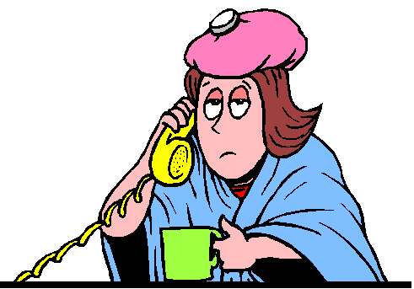

**Staff News**

Our Senior Practice Nurse Kitty Daisley is retiring in October after 25 years of nursing. She will be very much missed but we wish her well in this new, exciting chapter.



We welcomed a new receptionist in August, Siobhan Russell, and we hope she will enjoy working here.

**General Data Protection Regulation (GDPR)**

We still need to hear from many of our patients regarding their preferences about GDPR. If you have not already done so please let us know whether you are happy to receive text messages from us.

**Samples**

We can only process samples where the correct container has been used and where the information sheet has been completed in full. The reception staff can assist with any queries.

**Urinary Tract Infections (UTI’s)**

The NHS brought in new guidelines last year for treating female patients with uncomplicated urinary tract infections. If you are female aged 16-65 you should now contact your nearest pharmacy where you will be assessed and provided with antibiotics or advice as necessary.

Symptoms of a UTI include needing to pass urine suddenly or more often, pain or a burning sensation when passing urine, smelly or cloudy urine, pain in your lower tummy and feeling tired and unwell. In older people there can be changes in behaviour such as confusion or agitation.

**Appointments**

Please remember to cancel your appointment if you are no longer able to attend. If you have received a text message reminding you of your appointment you simply need to text back the word ‘cancel’. Otherwise please call us so that we can offer the appointment to another patient.

We offer appointments from 5.30pm to 6.15pm on Monday evenings for patients who find it difficult to attend at other times.

